**Project Behavioral Cloning**

**Vehicle Simulator:**

Link video: <https://www.youtube.com/watch?v=K8ROKGMm-mc>

**Intro to Behavioral Cloning Project**

Link video: <https://www.youtube.com/watch?v=YXs-IwG9ISg>

**Project Resources:**

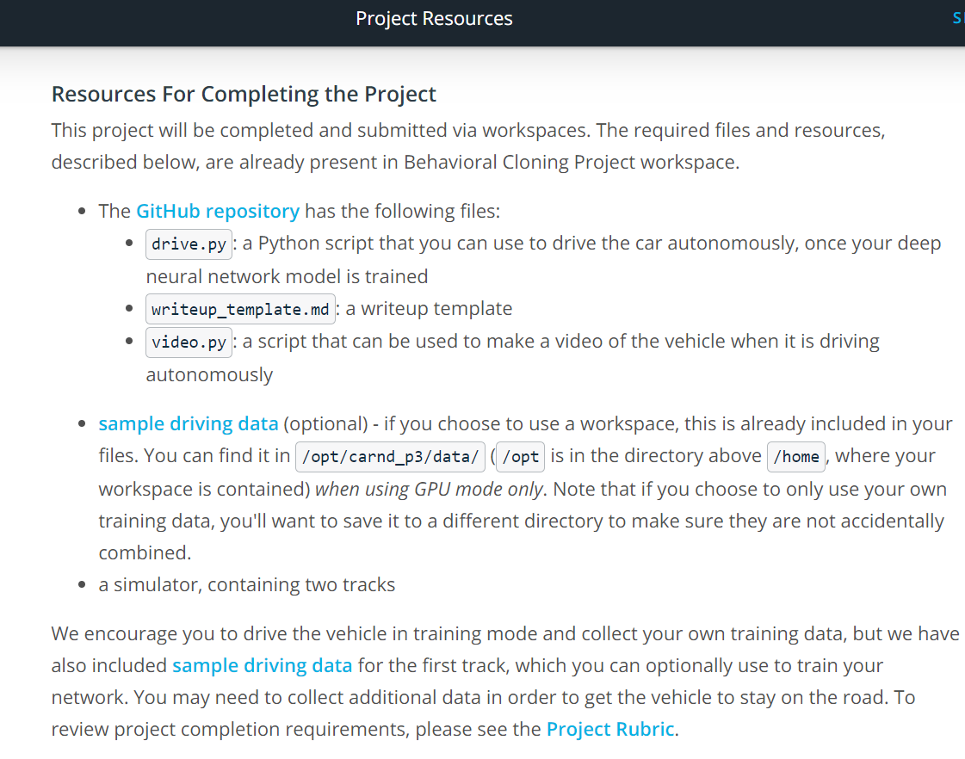

Github repository: <https://github.com/udacity/CarND-Behavioral-Cloning-P3>

Sample driving data: <https://d17h27t6h515a5.cloudfront.net/topher/2016/December/584f6edd_data/data.zip>

Sample driving data 2: <https://d17h27t6h515a5.cloudfront.net/topher/2016/December/584f6edd_data/data.zip>

Project Rubric: <https://review.udacity.com/#!/rubrics/432/view>

**Running the Simulator**

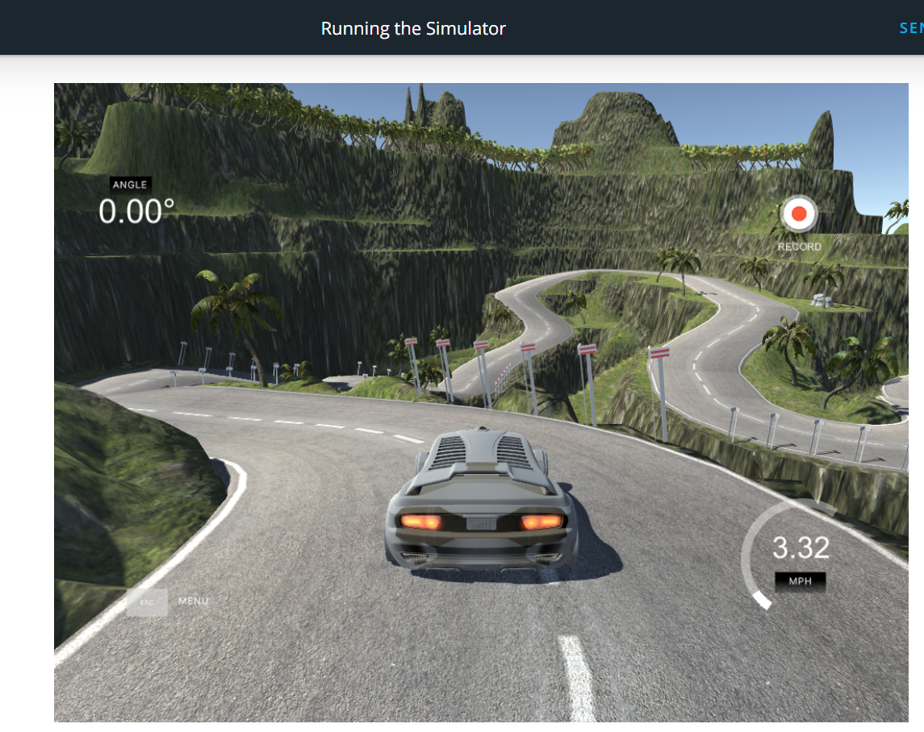

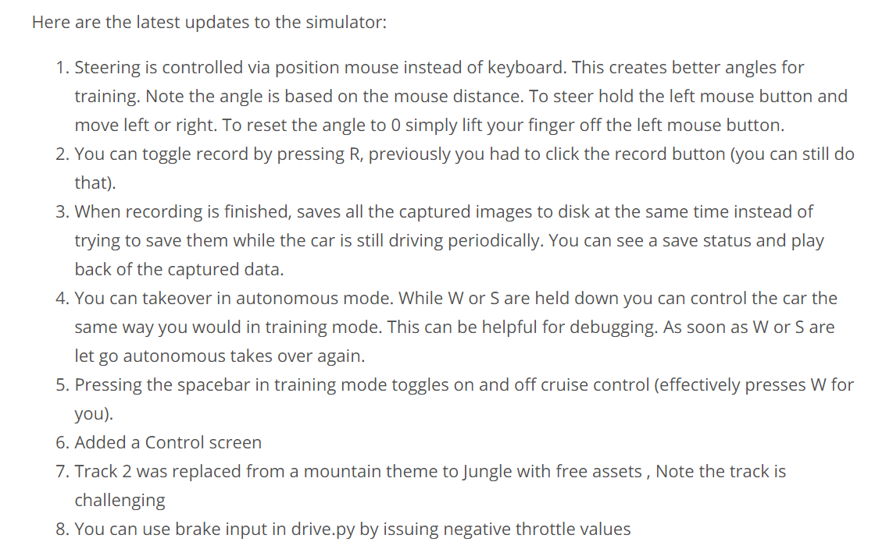

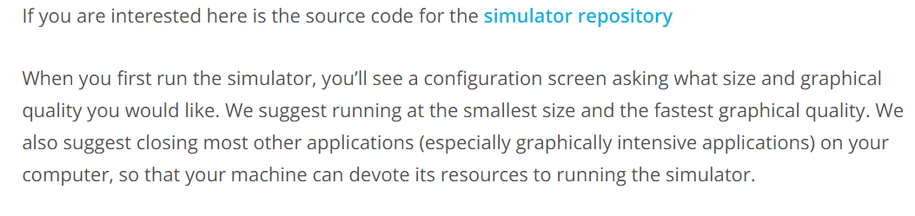

Link: <https://github.com/udacity/self-driving-car-sim>

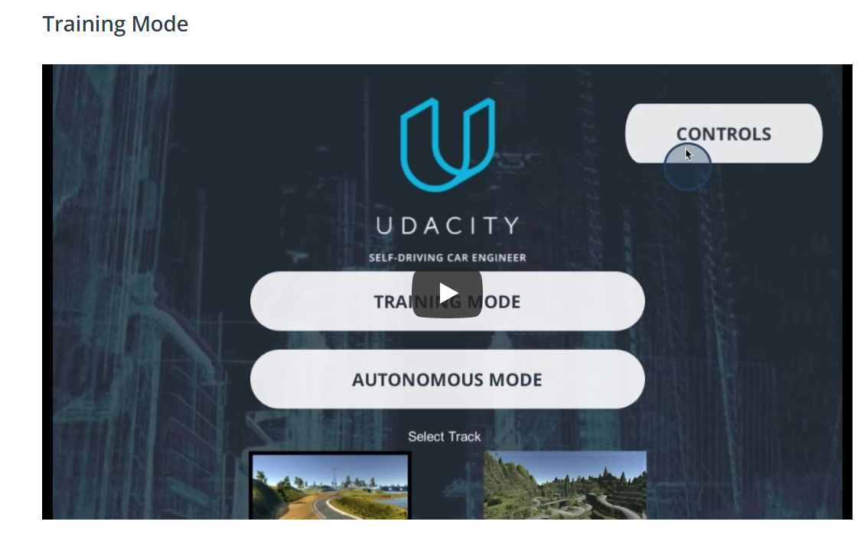

Link video: <https://www.youtube.com/watch?v=rKw8md-zVno>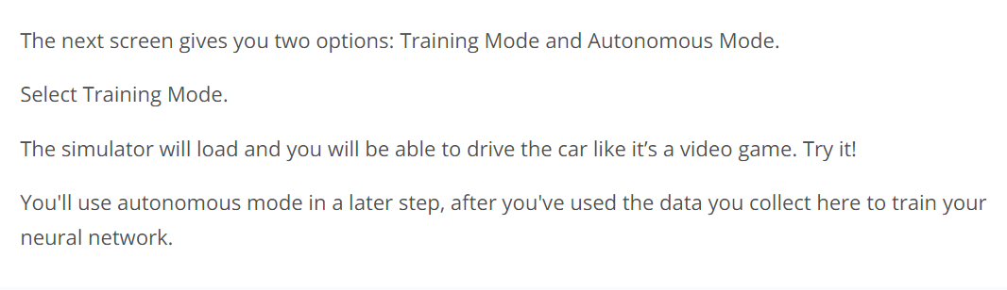

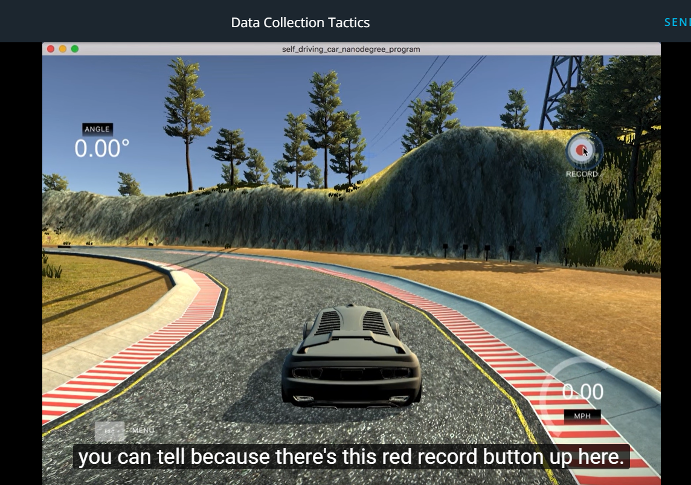

Link: <https://www.youtube.com/watch?v=kTJiHXJe_t4>

**Data Collection Strategies**

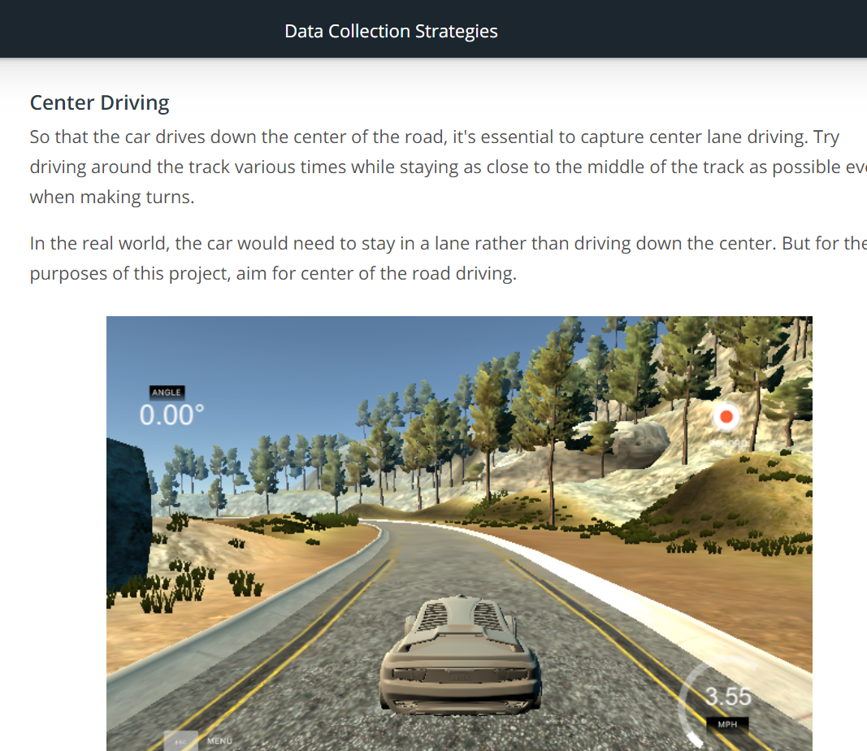

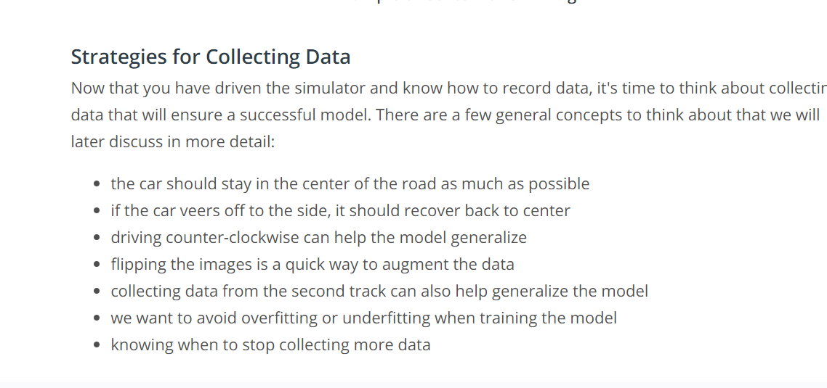

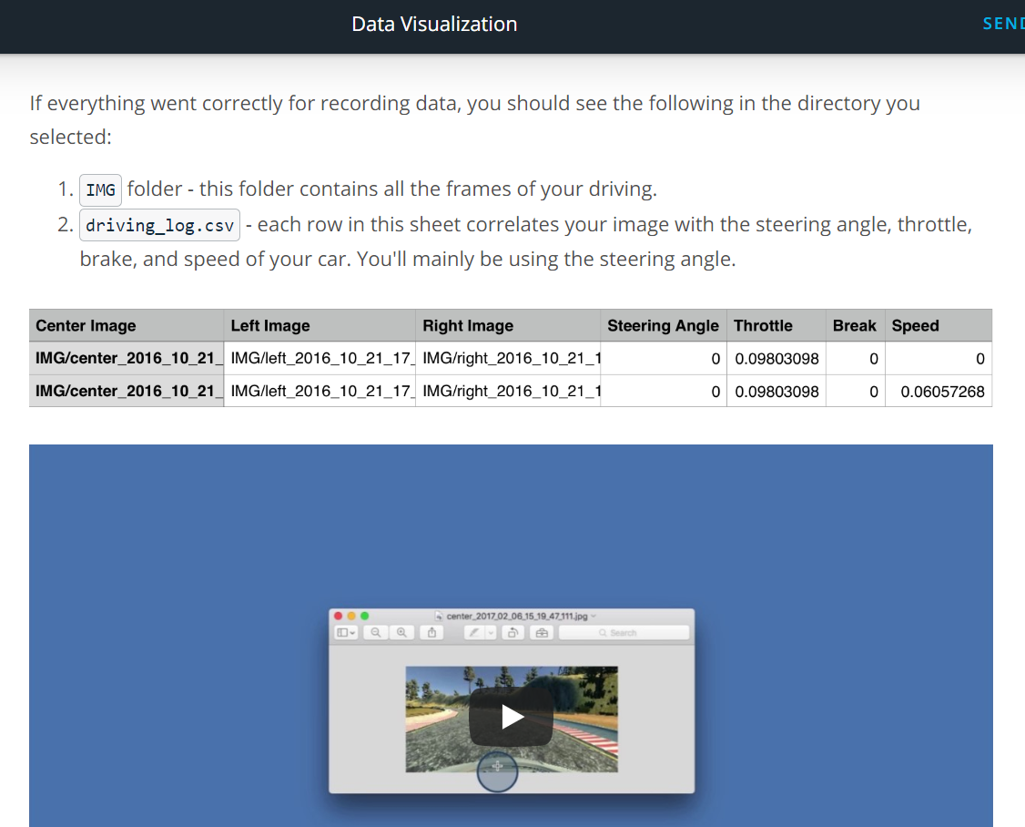

Link video: <https://www.youtube.com/watch?v=_Gto6fQQWFI>



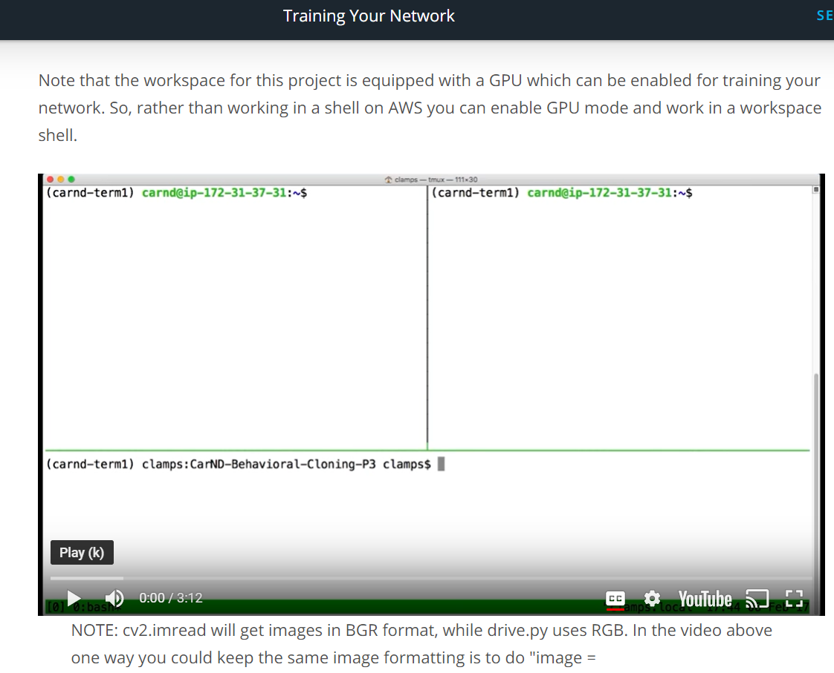Link video: <https://www.youtube.com/watch?v=iYH4UvsPgOY>

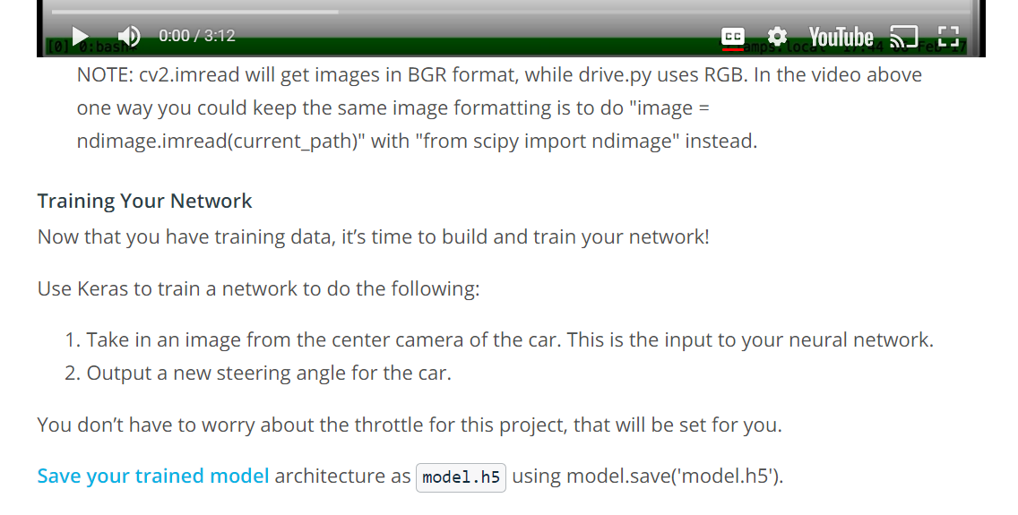

Link save your trained model: <https://keras.io/getting-started/faq/#how-can-i-save-a-keras-model>

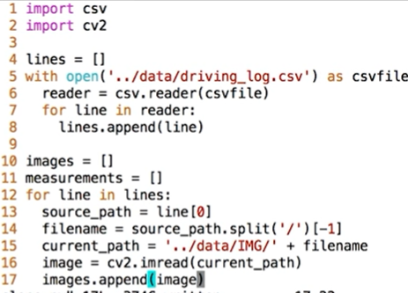

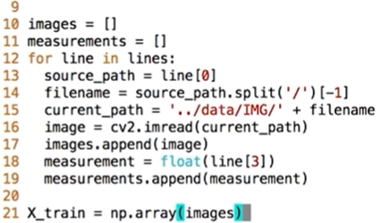

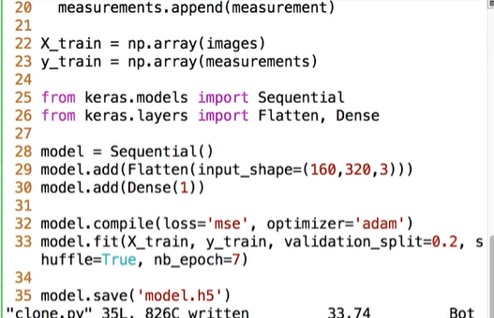

**Running your network**

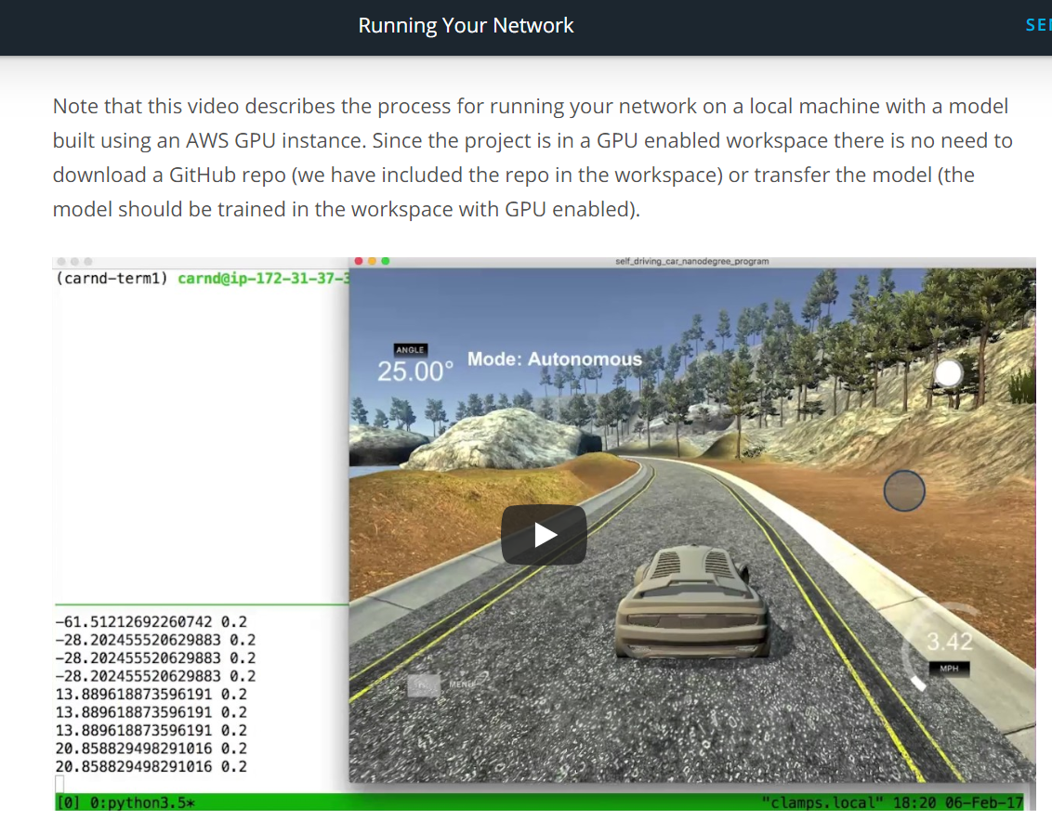

Link video: <https://www.youtube.com/watch?v=1UGOJGg-0dU>

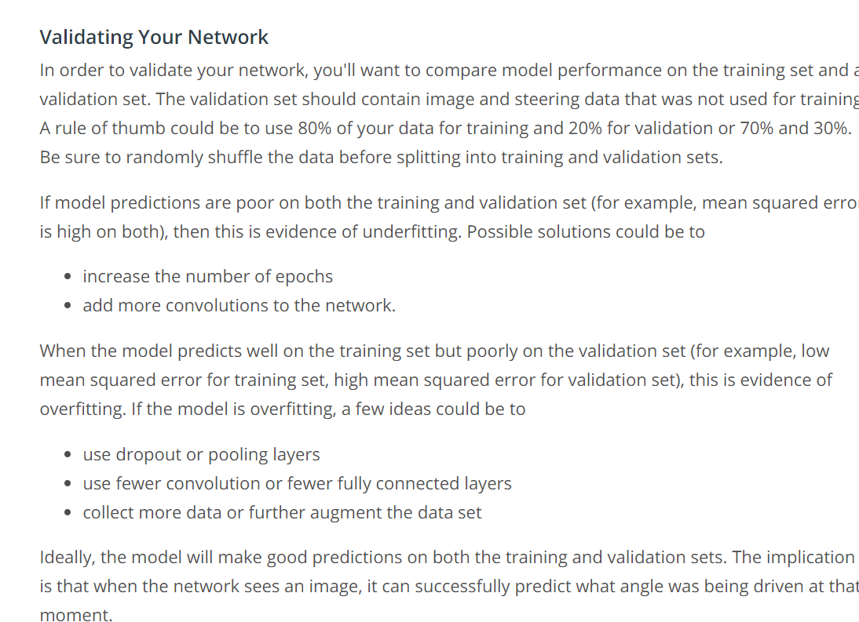

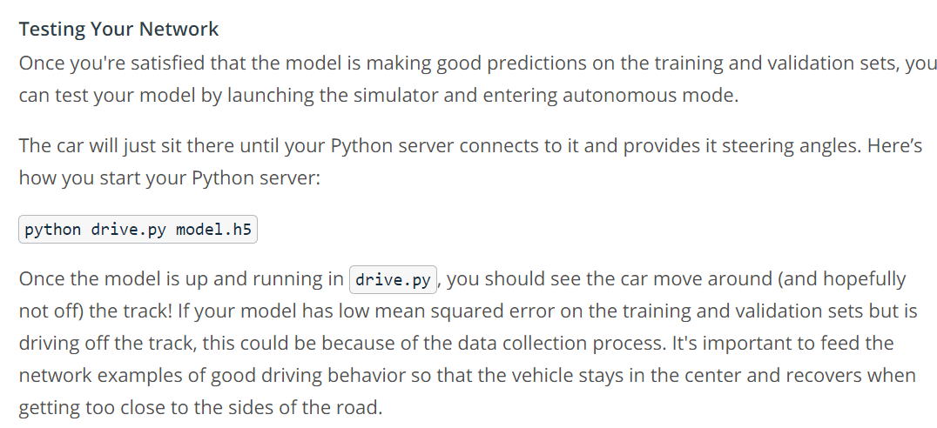

Lambda Layers

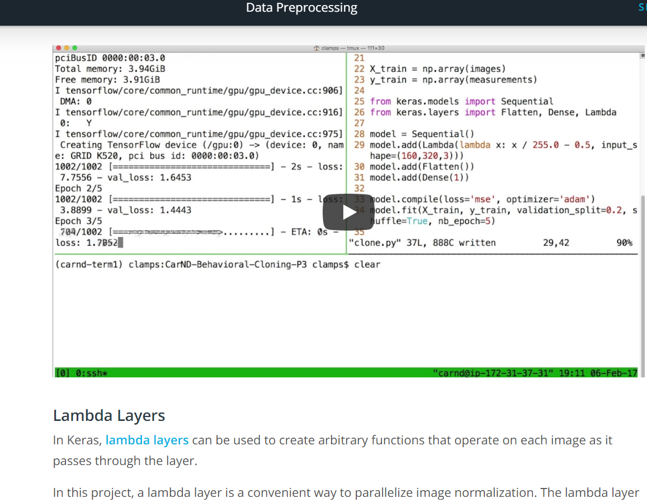

Link video: <https://www.youtube.com/watch?v=Oc7cLOS03PE>

In keras lambda layers: <https://keras.io/layers/core/#lambda>

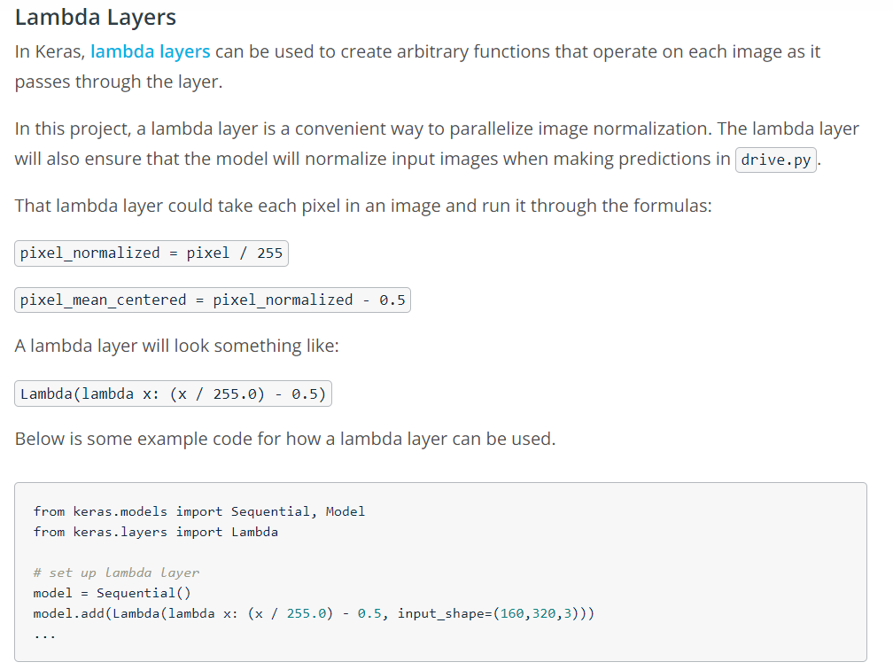

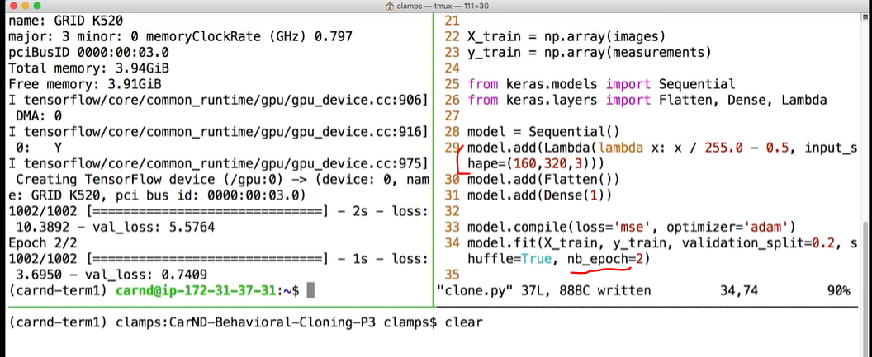

**More Networks**

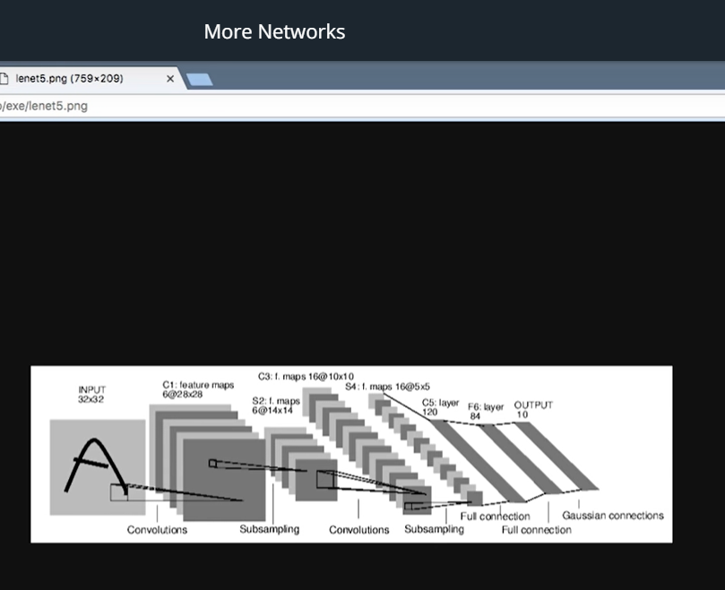

Link video: <https://www.youtube.com/watch?v=rVusn6F5i7s>

**Data Augmentation**

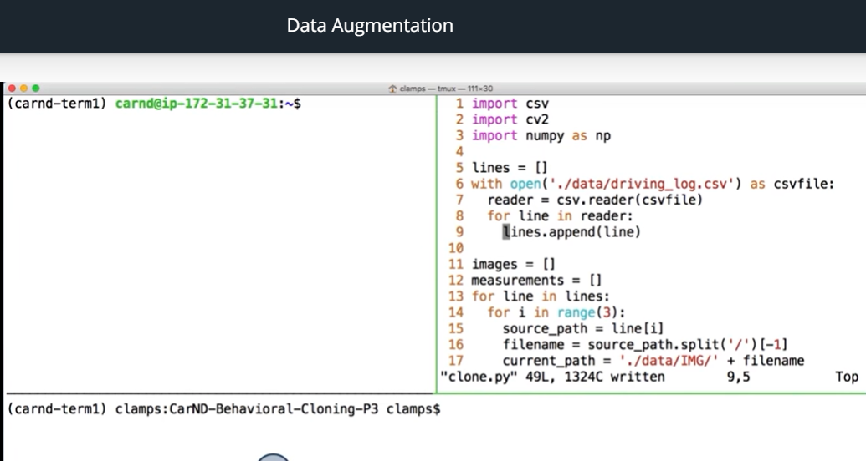

Link video: <https://www.youtube.com/watch?v=2oaB2_DhmF8>

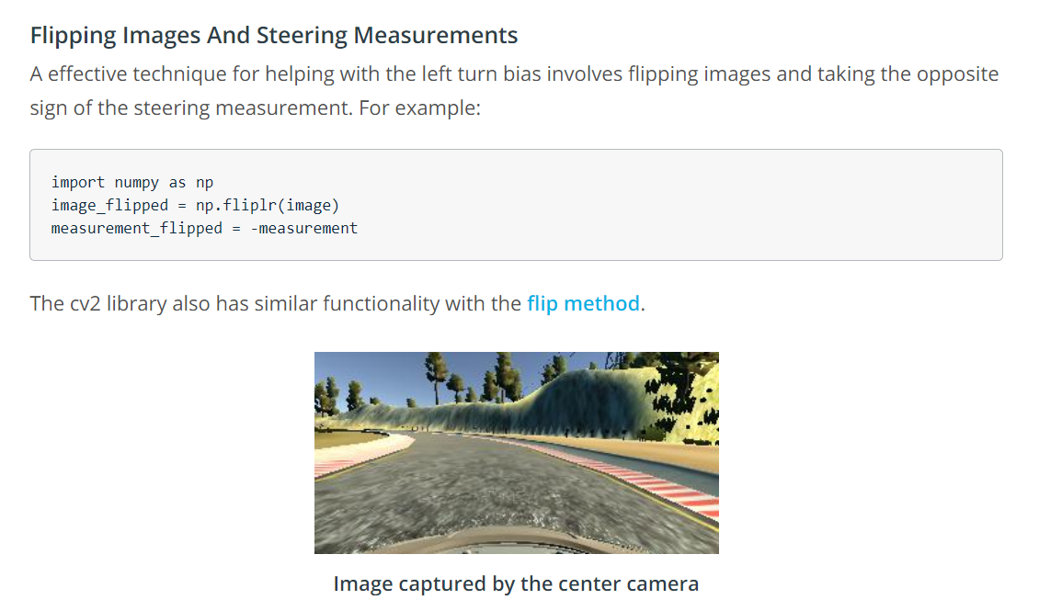

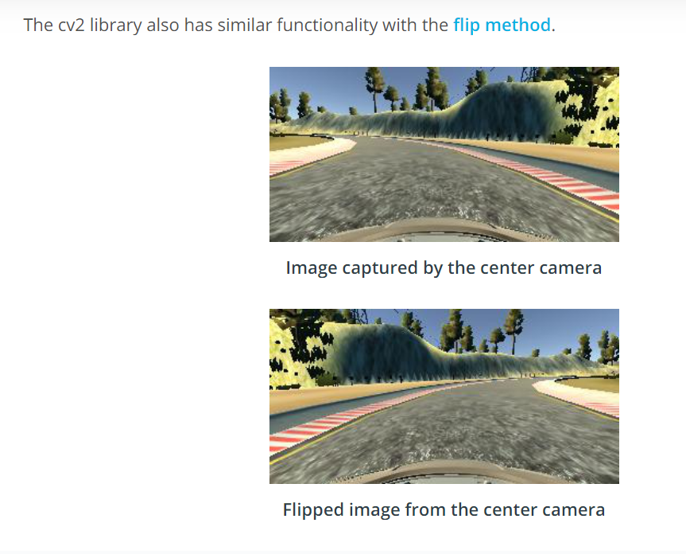

**Using Multiple Cameras**

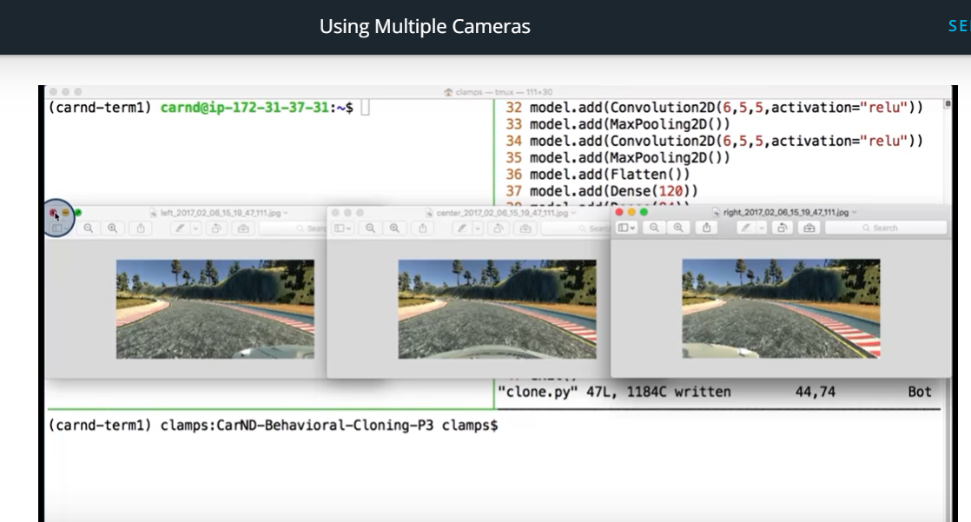

Link video: <https://www.youtube.com/watch?v=GumTdw9mjL0>

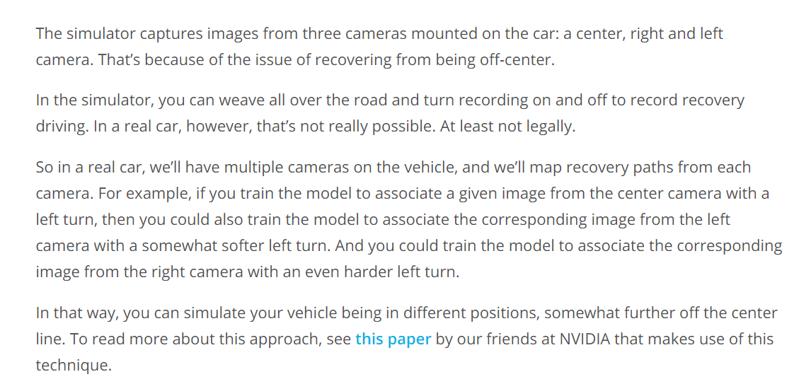

Paper: <http://images.nvidia.com/content/tegra/automotive/images/2016/solutions/pdf/end-to-end-dl-using-px.pdf>

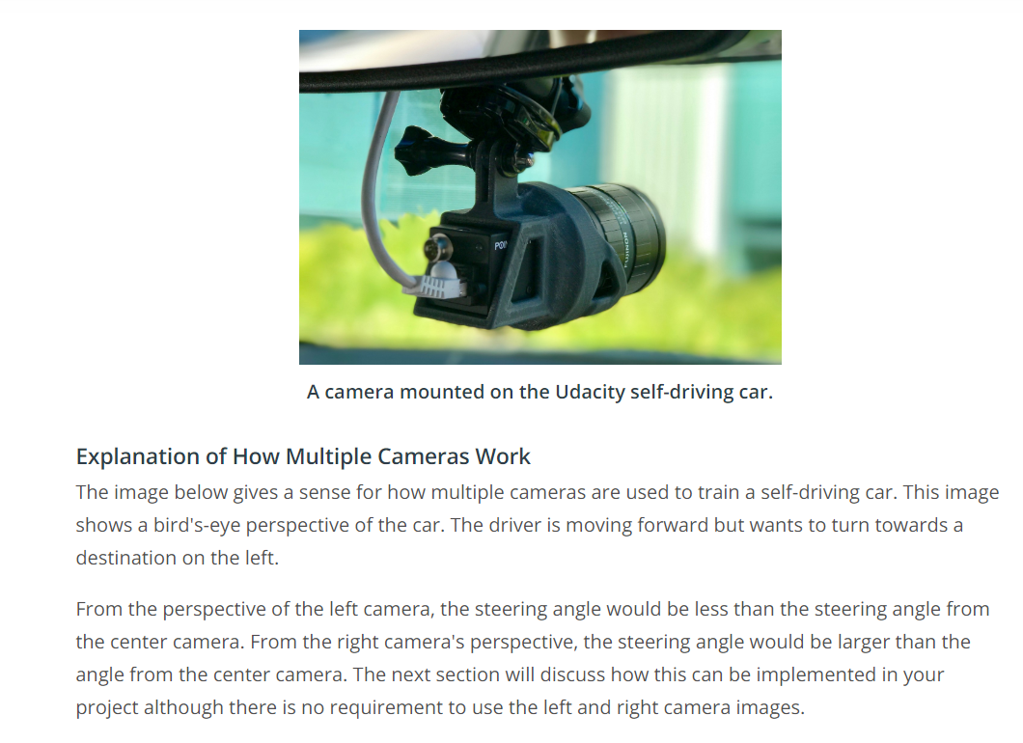

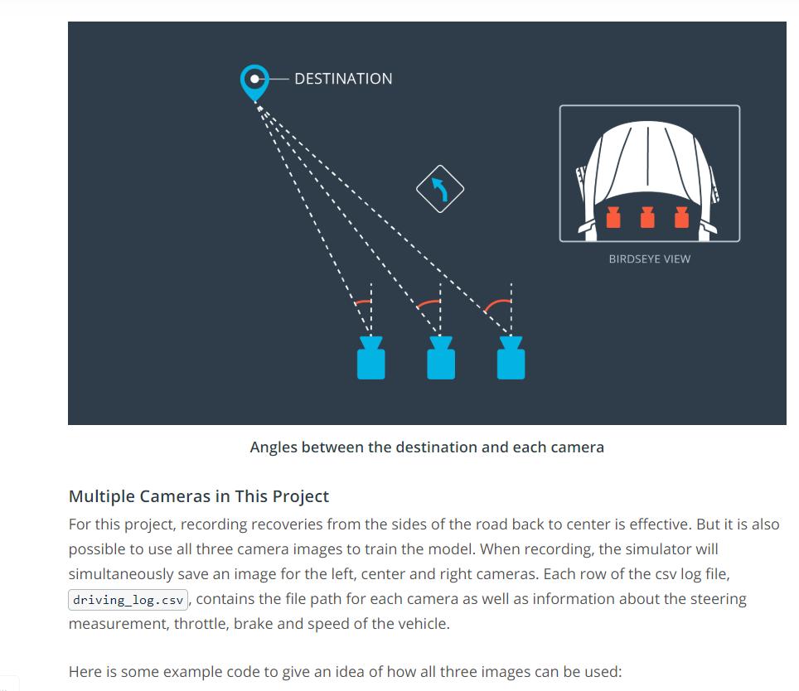

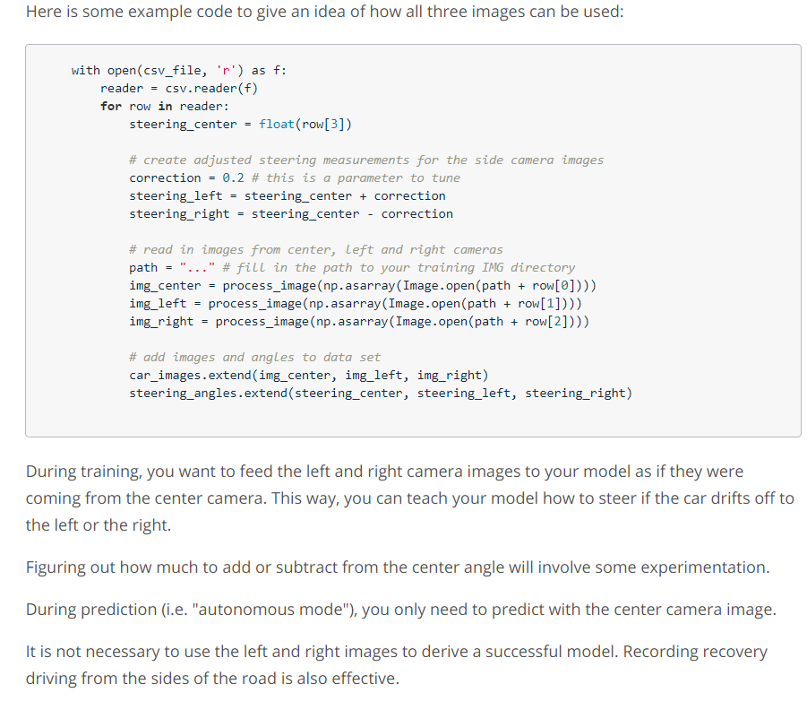

**Cropping Images in Keras**

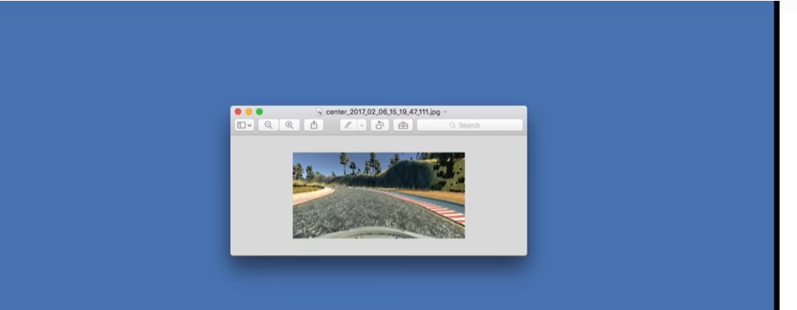

Link video: <https://www.youtube.com/watch?v=SpPxyW-869U>

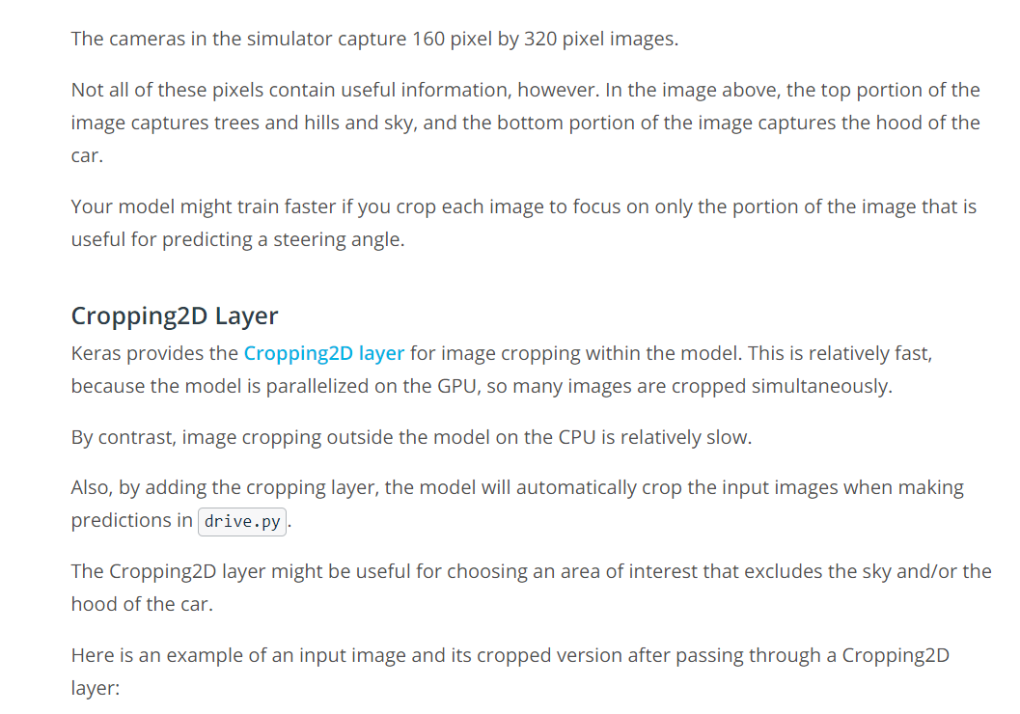

<https://keras.io/layers/convolutional/#cropping2d>

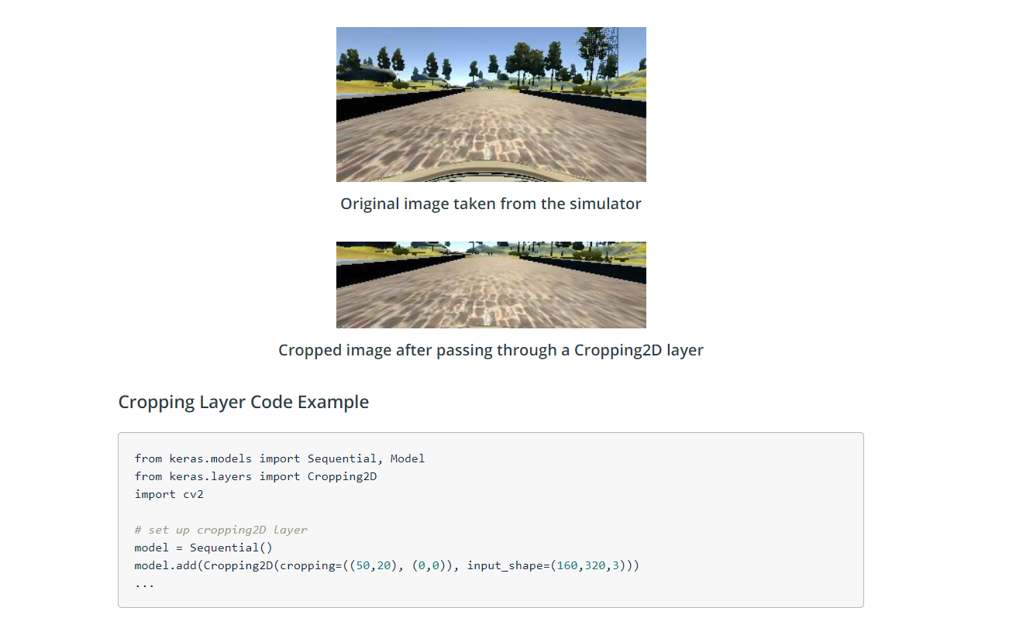

**Even More Powerful Network**

Link video: <https://www.youtube.com/watch?v=6vVPHcgQkLg>

**Mora Data Collection**

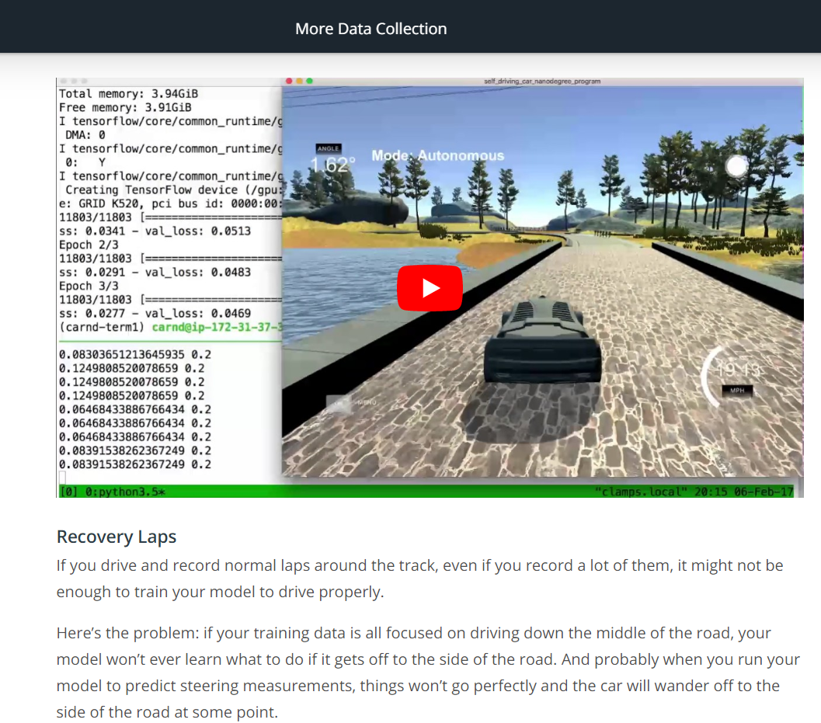

Link video: <https://www.youtube.com/watch?v=cCZNlX3KLnY>

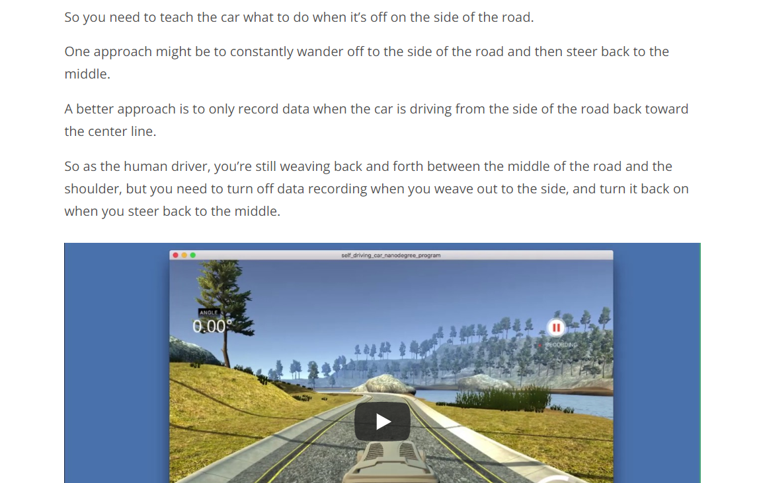

Link video: <https://www.youtube.com/watch?v=SfHOdOHf4Zk>

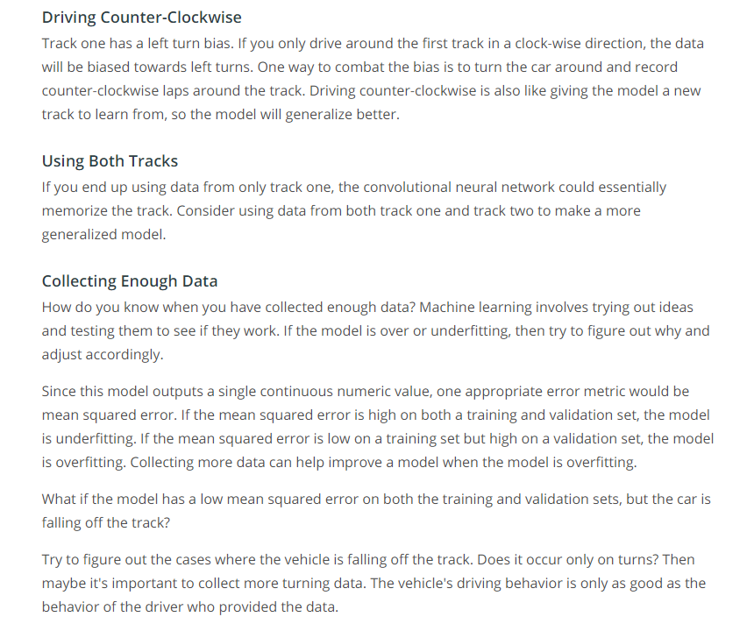

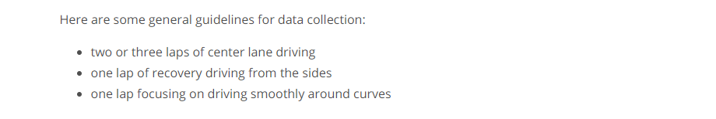

Visualizing Loss

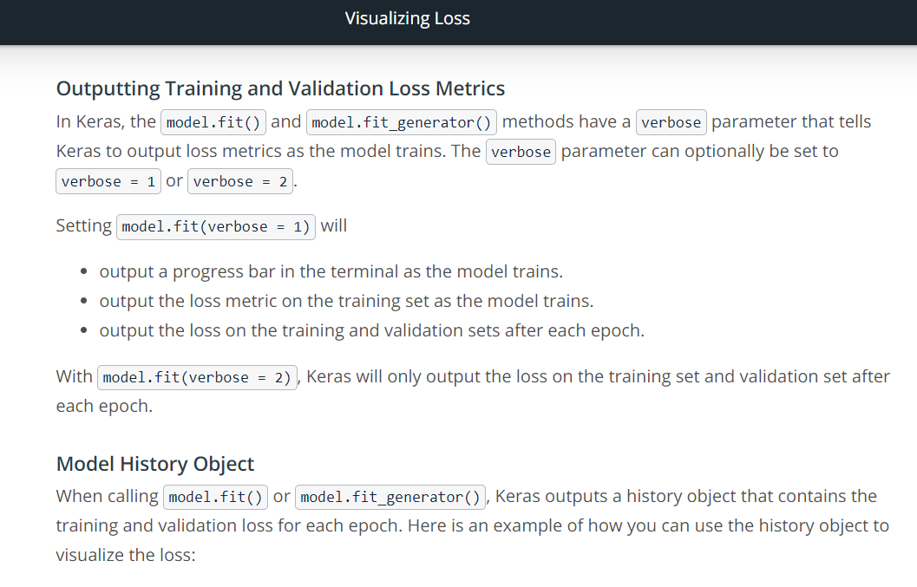

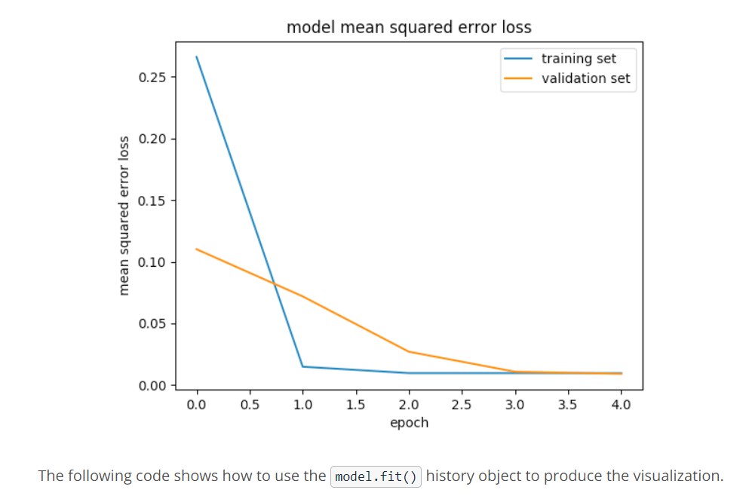

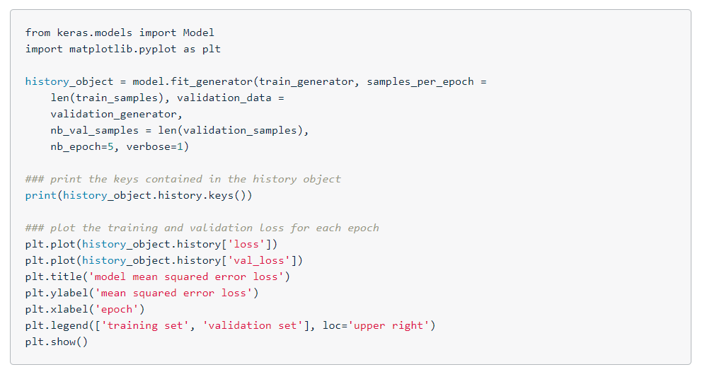

Generators

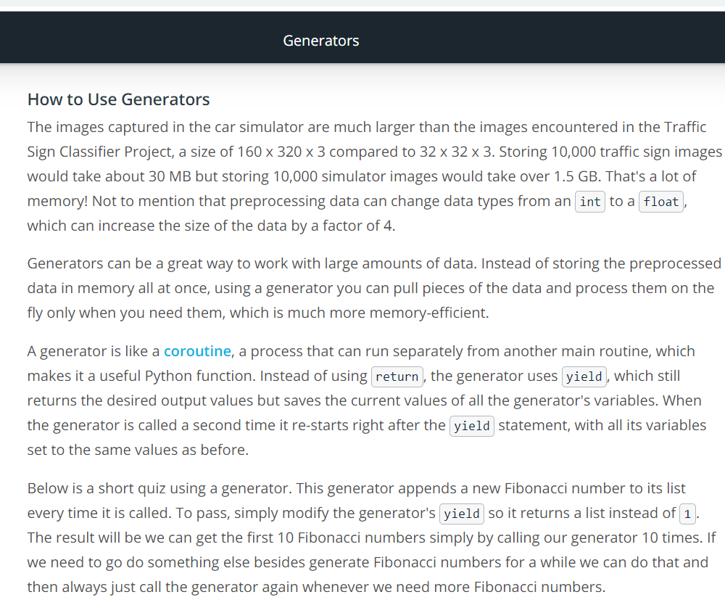

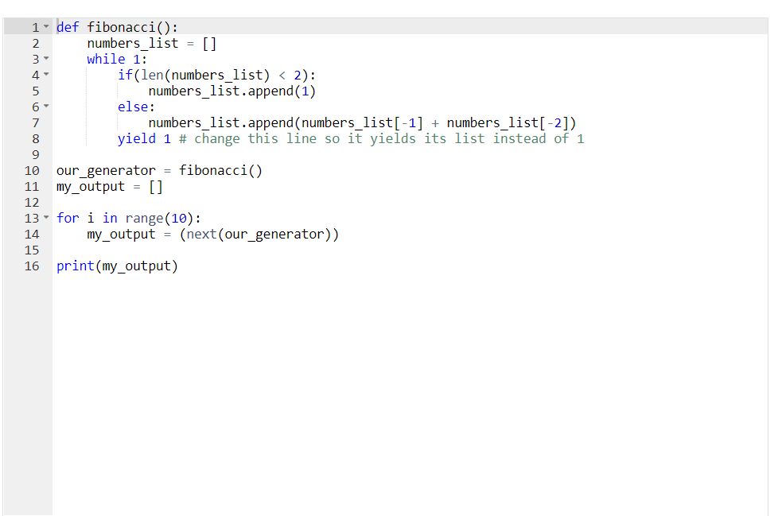

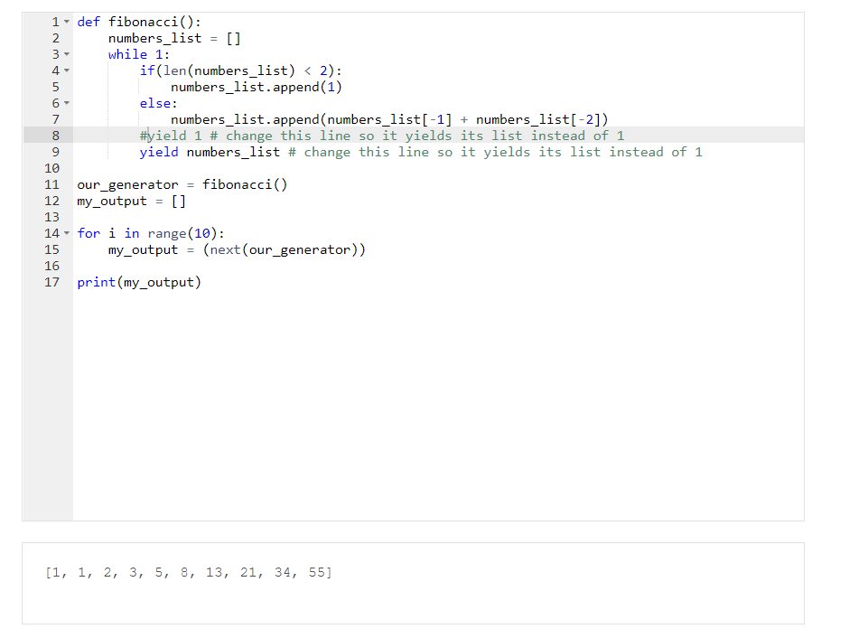

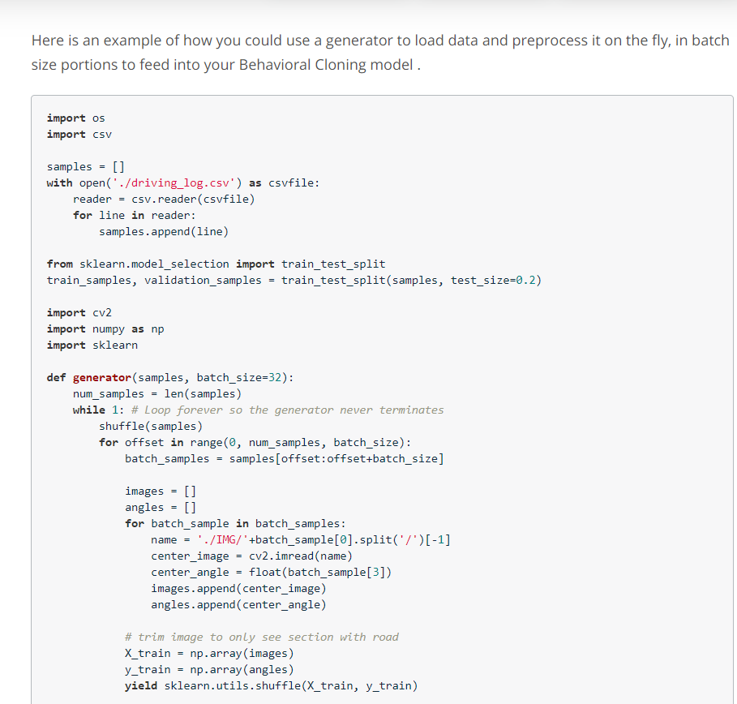

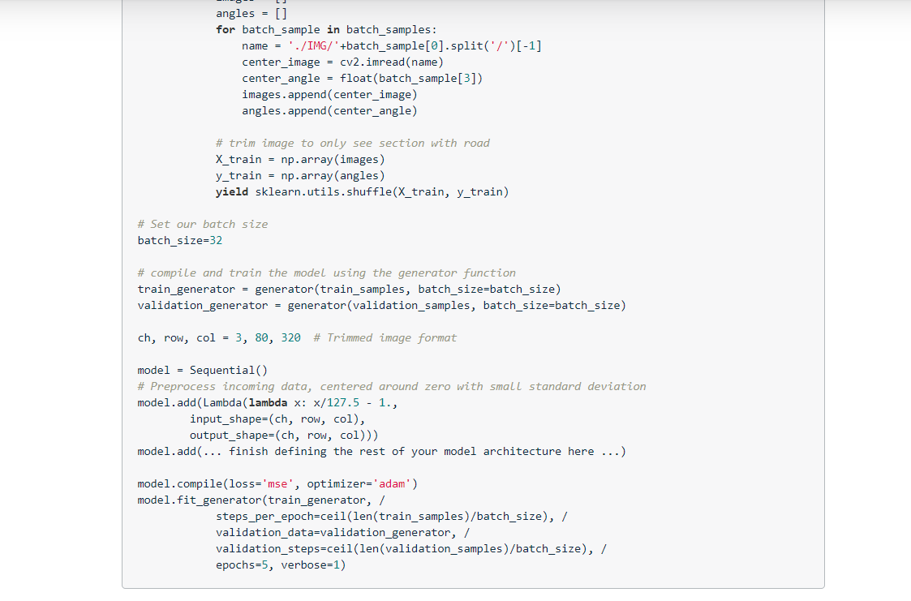

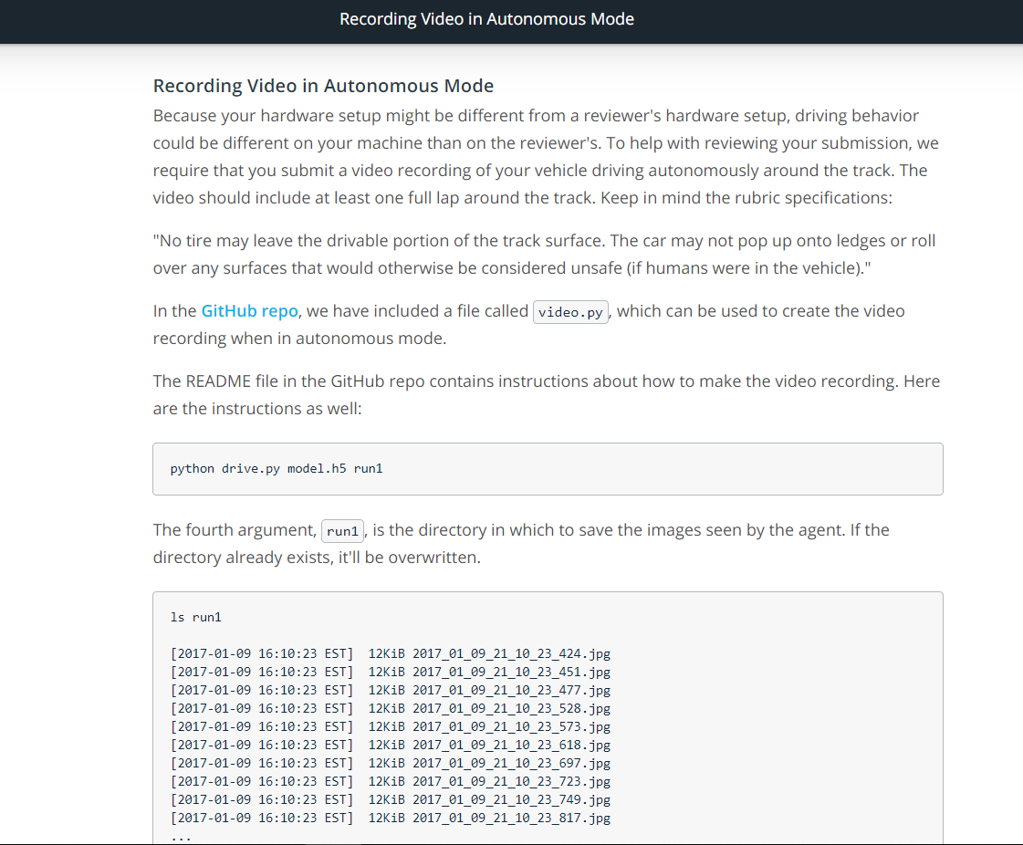

Link: <https://github.com/udacity/CarND-Behavioral-Cloning-P3>

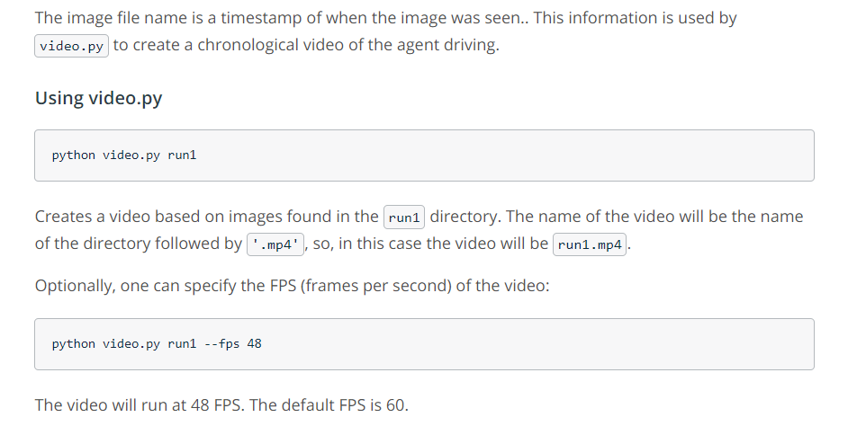

**Project Workspace Instructions**

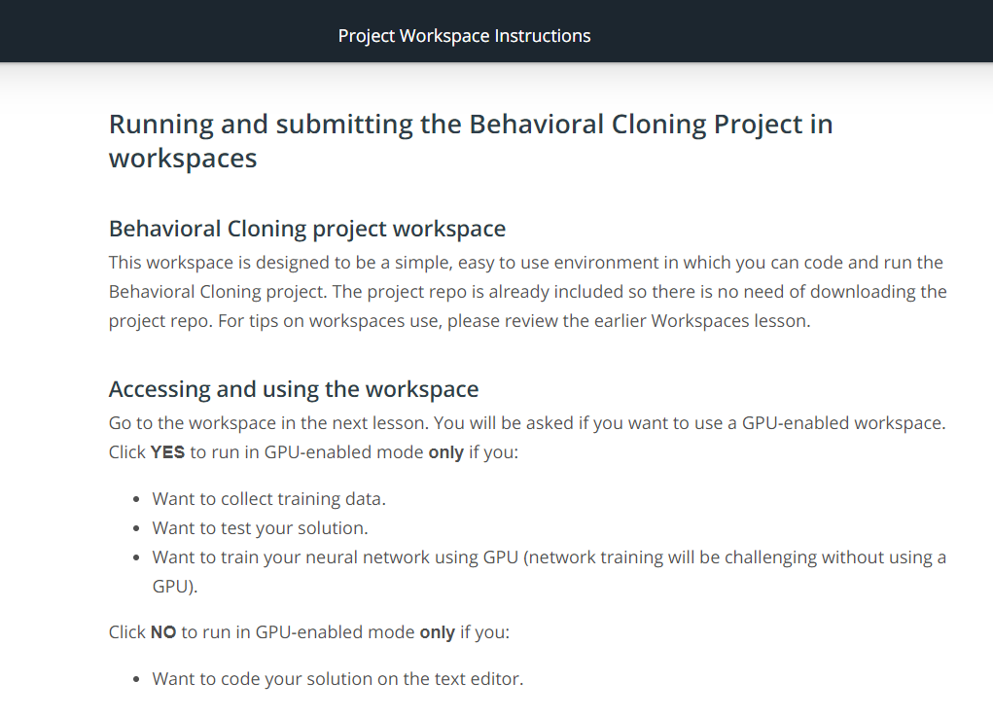

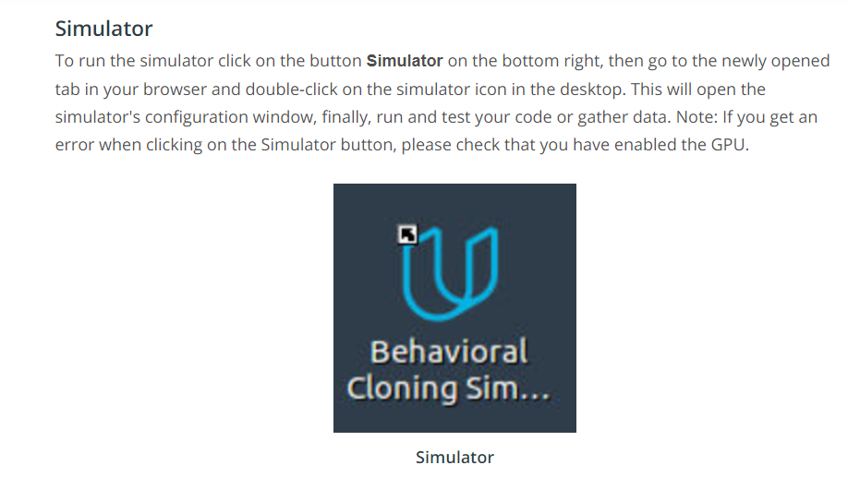

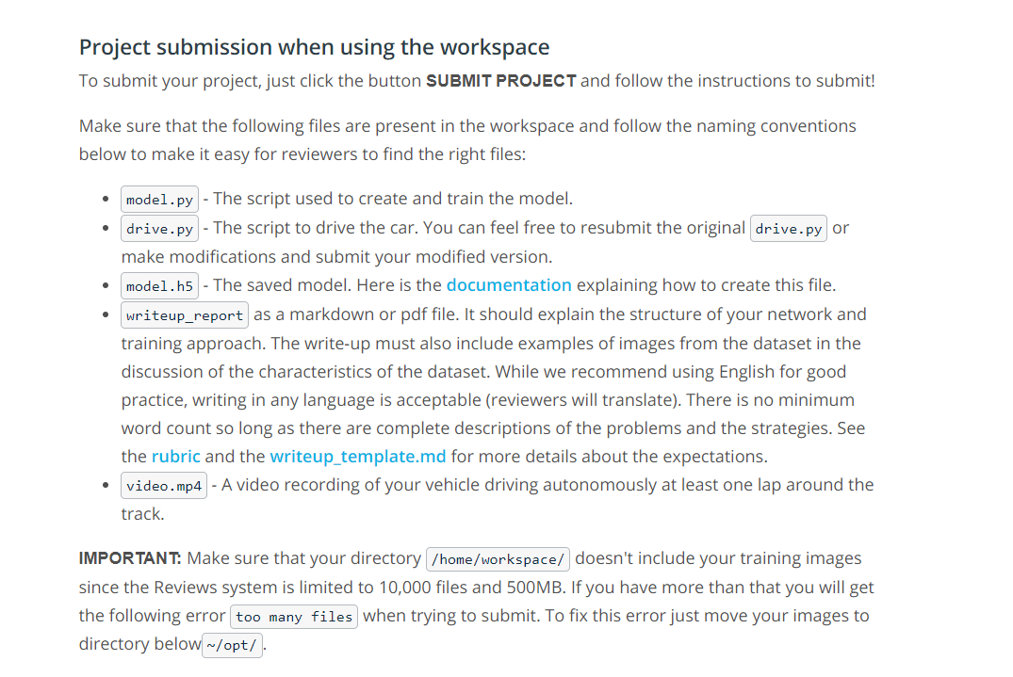

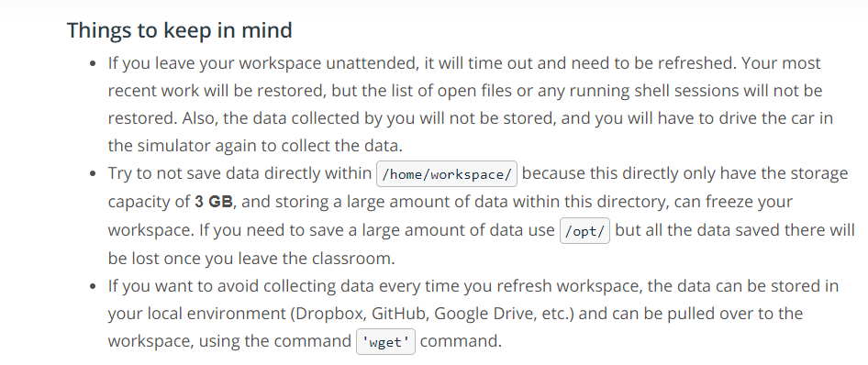

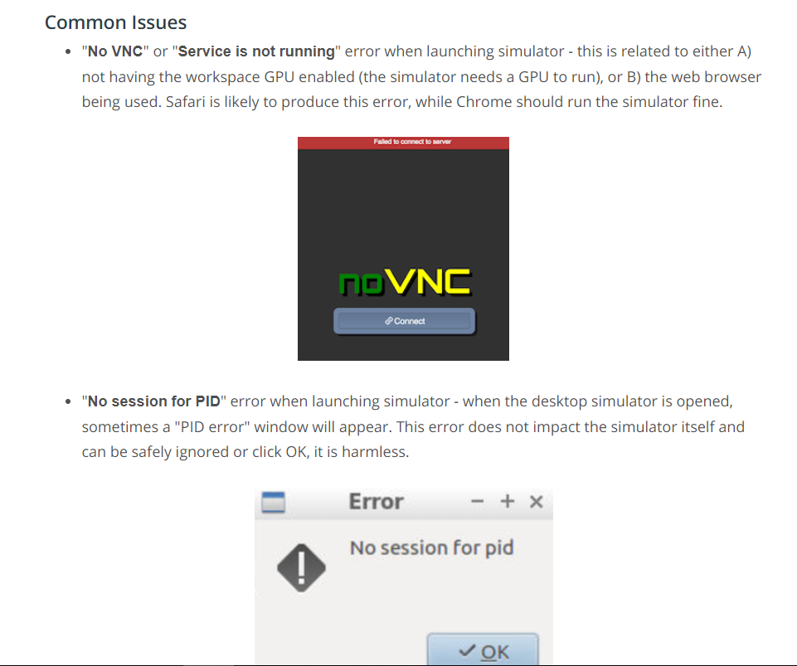

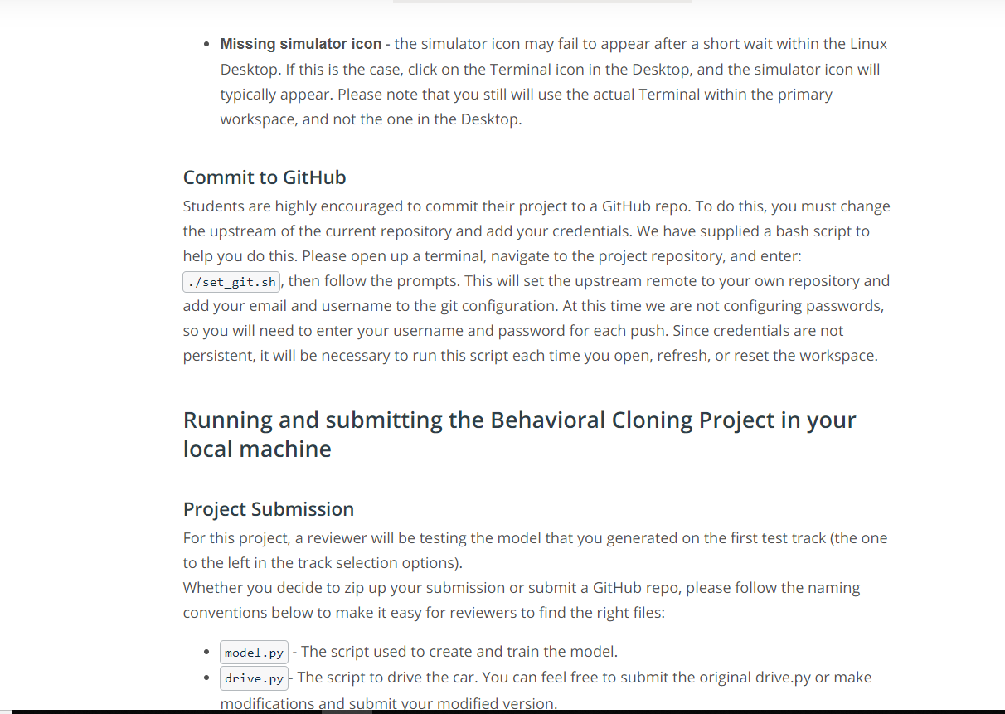

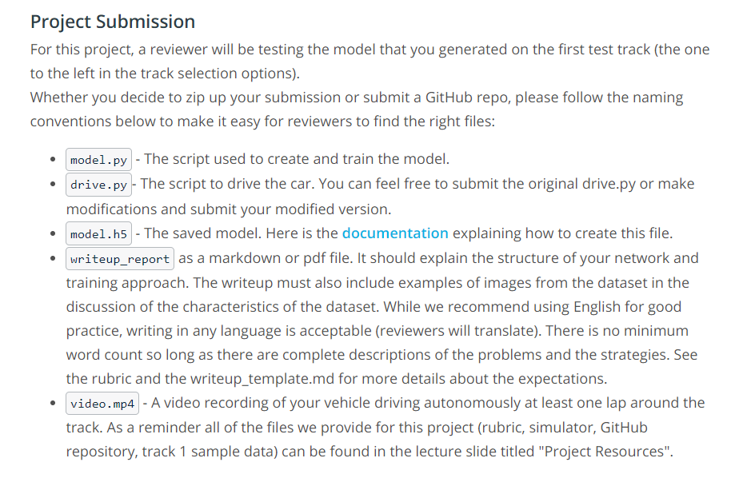

[**https://keras.io/getting-started/faq/#how-can-i-save-a-keras-model**](https://keras.io/getting-started/faq/#how-can-i-save-a-keras-model)

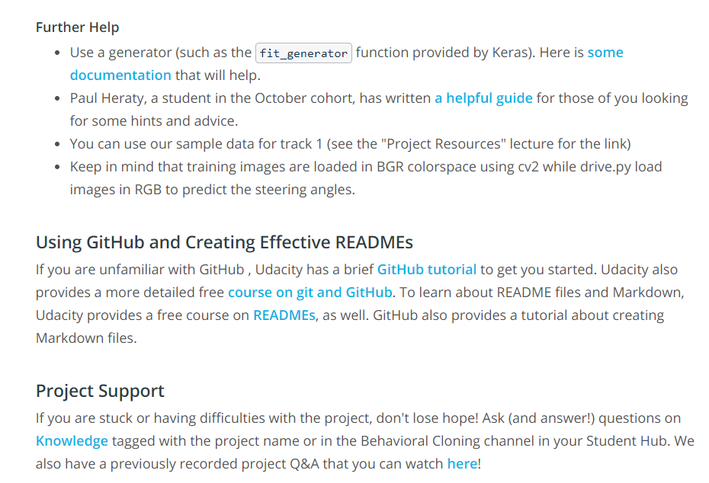

[**https://keras.io/models/model/#fit_generator**](https://keras.io/models/model/#fit_generator)

[**https://s3-us-west-1.amazonaws.com/udacity-selfdrivingcar/Behavioral+Cloning+Cheatsheet+-+CarND.pdf**](https://s3-us-west-1.amazonaws.com/udacity-selfdrivingcar/Behavioral+Cloning+Cheatsheet+-+CarND.pdf)

[**http://blog.udacity.com/2015/06/a-beginners-git-github-tutorial.html**](http://blog.udacity.com/2015/06/a-beginners-git-github-tutorial.html)

[**https://www.udacity.com/course/how-to-use-git-and-github--ud775**](https://www.udacity.com/course/how-to-use-git-and-github--ud775)